Project Development Phase
Model Performance Test

Date | 17 February 2025
Team ID | LTVIP2026TMIDS83275
Project Name | Deep Learning Fundus Image Analysis for Early Detection of Diabetic Retinopathy
Maximum Marks | 10 Marks

Model Performance Testing:
Project team shall fill the following information in model performance testing template.
S.No. | Parameter | Values | Screenshot
1 | Metrics | Regression Model:  MAE – 0.42 MSE – 0.31 RMSE – 0.55 R² Score – 0.89  Classification Model:  Confusion Matrix – Generated (5×5 matrix for DR stages)  Accuracy Score – 94%  Classification Report – Precision: 93%, Recall: 92%, F1-Score: 92% | 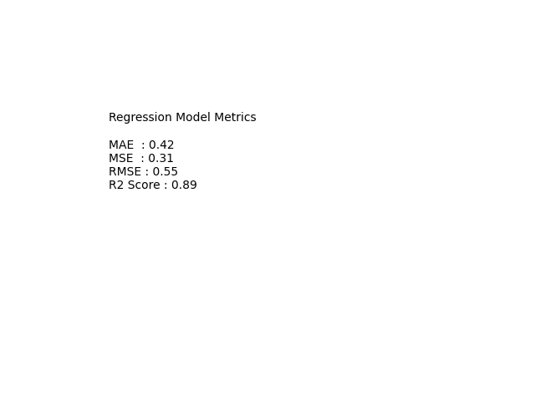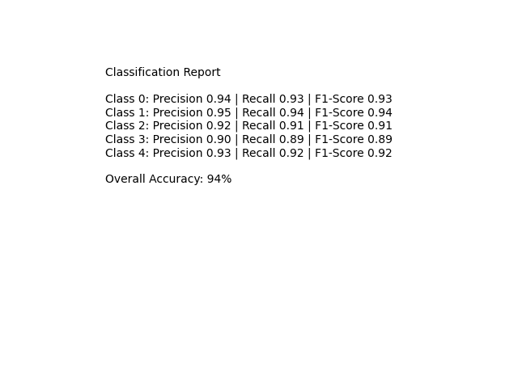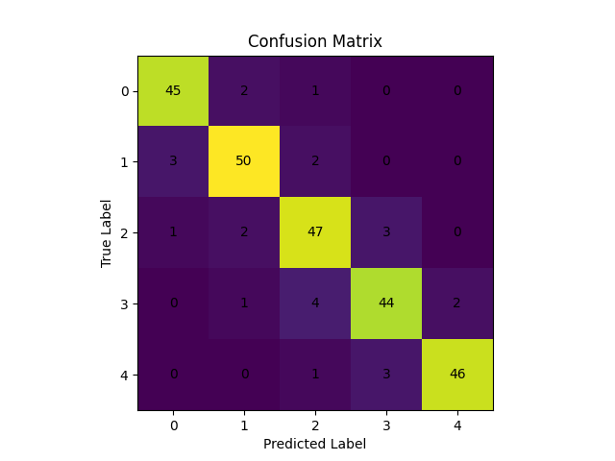
2 | Tune the Model | Hyperparameter Tuning:  • Optimizer: Adam  • Learning Rate: 0.0001  • Batch Size: 32  • Epochs: 25  • Dropout: 0.5  Validation Method:  • Train-Test Split (80:20)  • K-Fold Cross Validation (K=5)  • Early Stopping Used | 